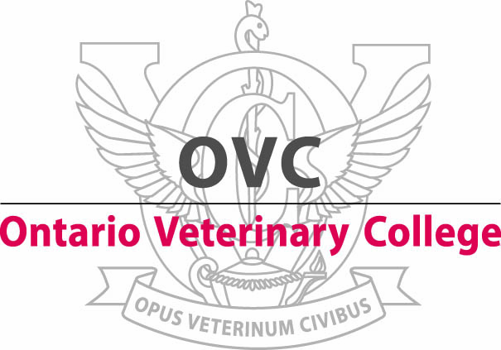

**FACULTY POSITION**

**3 year Contractually Limited**

**Large Animal Emergency Medicine and Surgery- Department of Clinical Studies**

The Department of Clinical Studies, Ontario Veterinary College (OVC), is seeking applications to fill a 3 year contractually limited faculty position in Large Animal Emergency Medicine and Surgery at the rank of Assistant Professor.

Applicants must have a DVM degree (or equivalent) and be licensed or eligible for licensure to practice in the Province of Ontario. Preference will be given to Diplomates of the American College of Veterinary Surgeons (ACVS). Applications may also be considered from candidates who are Diplomates of the European College of Veterinary Surgeons (ECVS) or who have completed an ACVS or ECVS approved residency training program. The ideal candidate should have a strong background in clinical emergency large animal medicine and surgery and outstanding communication skills. The ability to work with others in a collegial team atmosphere is essential.

The successful candidate will join a team of 3 faculty members in Large Animal Surgery, 3 faculty members and one Veterinarian in Large Animal Internal Medicine and 3 faculty members in Anesthesia. Clinical teaching and service related to emergency out-of-hours large animal patients in the OVC Health Sciences Centre will be the major responsibilities of the position. Provision of clinical teaching to fourth year DVM students, interns, and residents of other disciplines, along with training and mentoring of residents in large animal disciplines is expected. The remaining effort is to be spent on service and scholarly activity.

The faculty and staff of the Department of Clinical Studies and the OVC Health Sciences Center are committed to delivering the very best of patient care.

Guelph is a vibrant community of approximately 130,000 people, located in Southern Ontario, 100 kilometers west of Toronto.  For more complete information about the city please refer to the City's web site at [www.guelph.ca](http://www.guelph.ca)

The deadline for applications will be June 2, 2017. Interested parties should contact Dr. Carolyn Kerr, Chair, Department of Clinical Studies, Ontario Veterinary College, University of Guelph, Guelph, Ontario, N1G 2W1 (519) 824-4120 ext: 54051, Fax 519-767-0311, email: [searchcv@uoguelph.ca](mailto:searchcv@uoguelph.ca) and provide a letter of application, current curriculum vitae and the names of at least three referees.

All qualified candidates are encouraged to apply; however, Canadians and permanent residents will be given priority.

The University of Guelph is committed to an employment equity program that includes special measures to achieve diversity among its faculty and staff. We therefore particularly encourage applications from qualified aboriginal Canadians, persons with disabilities, members of visible minorities and women.