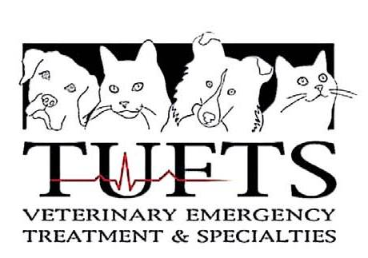

Hospital Director
Tufts Veterinary Emergency Treatment and Specialties
www.tuftsvets.org

Tufts Veterinary Emergency Treatment and Specialties is a community based, veterinary specialty hospital serving referring veterinarians and their clients south and west of Boston, in Walpole, Massachusetts. Tufts VETS also serves as a teaching hospital for Cummings School of Veterinary Medicine, with a shared Emergency Critical Care residency program and elective clinical rotations for Cummings’ DVM students. Tufts VETS’ doctors and staff work in partnership with its referring veterinarians providing compassionate, high quality specialty, emergency and critical care to their small animal patients. Tufts VETS’ 23 doctors and 66 staff work in a well-equipped, 15,000 square foot specialty hospital, convenient to Routes 1, 95, 495 and 128.

The Tufts VETS Hospital Director is the full charge medical and administrative leader responsible to ensure that the hospital provides high quality clinical care to veterinary patients, quality service to referring veterinarians and clients, and enriching clinical learning opportunities for residents, interns and veterinary students in a successful veterinary business model.

A veterinary degree is required along with five years of management, supervisory and leadership experience. Applicants must possess or be eligible to obtain a Massachusetts veterinary license and DEA certificate. Specialty board certification preferred.

The position will be available on July 1, 2014 and the search will be continued until a suitable candidate is identified. Applicants should include a letter of intent outlining their interests, experience and qualification, current curriculum vitae, and the names of 3 professional references to:

Joseph McManus
Executive Associate Dean
Cummings School of Veterinary Medicine at Tufts University
200 Westboro Road
North Grafton, MA 01536

Inquiries can be directed to Joe McManus at (508) 887-4734 or joseph.mcmanus@tufts.edu

Tufts Veterinary Emergency Treatment and Specialties practice is an AA/EO employer and actively seeks candidates from diverse backgrounds.

